Has

Review

AppointMentApproved

Login

Had

Observation

Had

Schedule

Doctor

Has

Patient

TABLES

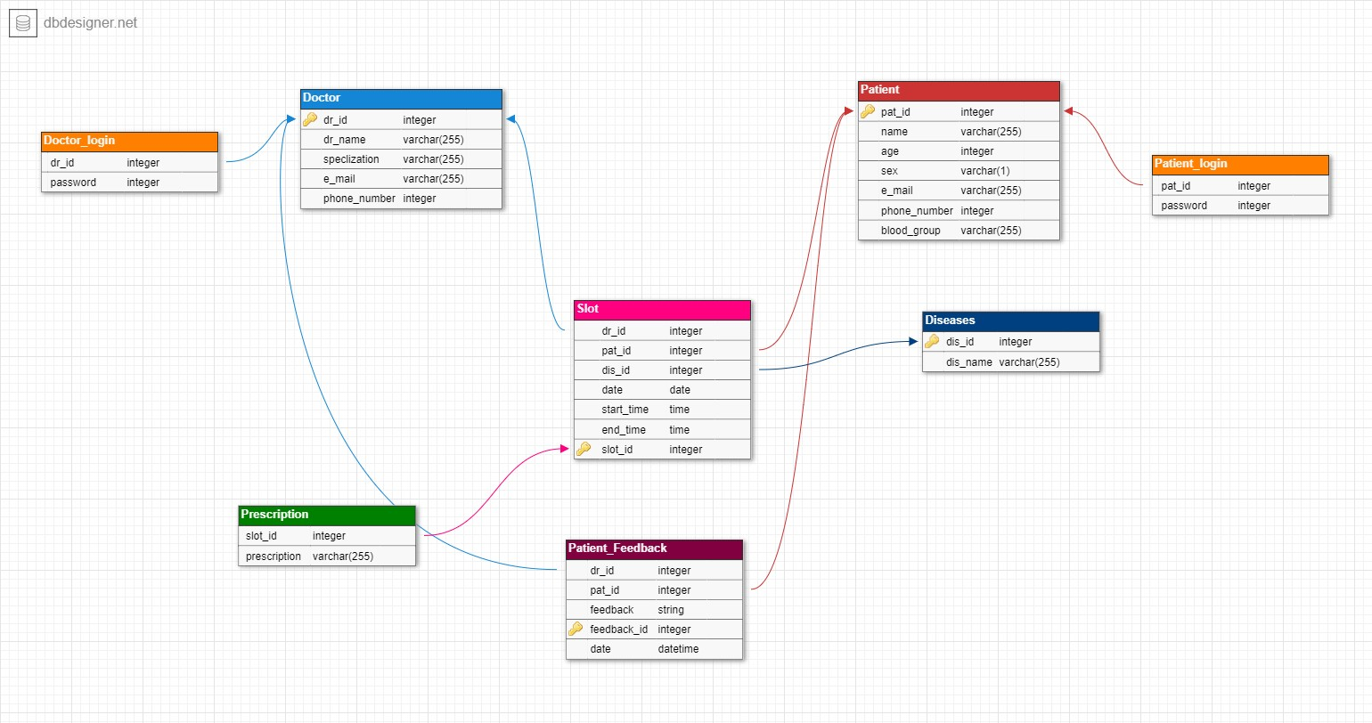

|  |  |  |
| --- | --- | --- |
| Class | Attributes | Methods |
| Doctor | Doc_Id  Doc_name  Specification  ContactNumber | addDoctor()  updatePhoneNumber()  addSpeciliztion() |
| Patient | Pat_Id  Pat_Name  Age  ContactNumber  Consultant History | addPatient()  updateContactNumber() |
| Dieases | Dis_Id  Dis_Name | addDisease() |
| Login |  | DocLogin(Doc_Id,Password)  PatientLogin(Pat_Id, Password)  Changepassword(Doc_Id/Pat_Id,Password,newpassword) |
| Slot | Slot_Id  Date  Time | bookSlot(Pat,doc,date,time) |
| Patient_Feedback | feedback | addFeddBack(Doc,Pat) |

CLASS, METHODS AND ATTRIBUTES: